# Inductor Tests

Two tests are conducted for the design of the inductor. In the first one, the inductance of the inductor is tested with 10A DC bias and effect of the saturation will be observed. In the second test the heating of the inductor is observed with 10 A DC.

## Inductance Test

In this test the inductance is observed when 10A is passing through the core. In other words, the effect of the saturation on the inductance will be observed. It is aimed that the inductance will be close to 120 µH.

In order to test the inductance, the following setup given in Figure 1 is constructed.

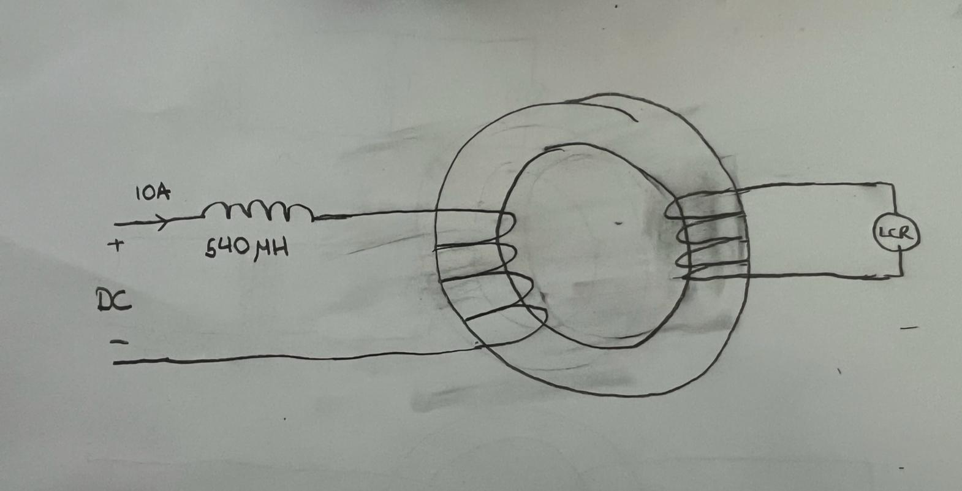

Figure 1 Inductance Test Setup

Two windings are wound to the inductor. The one on the left carries the DC 10A current which will saturate the core. For this winding the H07V-K with 1.5 mm2 copper area is used. The second winding is used to measure the inductance with LCR meter. This circuit acts as a transformer; hence the inductance of the core can be calculated under 10 A DC bias. Since LCR meter applies a small voltage to measure inductance, a thinner cable can be used. In this case AWG15 is used. The equivalent circuit which is seen by the LCR meter of this setup is provided in Figure 2.

Figure 2 Equivalent Circuit Seen by the LCR Meter

Since the switching frequency is 50 kHz the LCR meter is arranged to apply 50 kHz 1Vpp voltage. Since there are large capacitors inside the DC supply from LCR meters point of view that part is shorted. Thus, if 660 µH is not used at the input side the value that is read by the LCR meter will be as follows.

Since leakage inductance is much smaller than the wound inductance the measured inductance will be approximately 2Lleakage. Thus, a higher inductor, which is 660 µH, is connected to the DC side so that the measured inductance will be as follows.

The inductance is measured as 106 by the LCR meter. This will yield which shows the inductor design is successful.

## Inductor Heating Test

In this part the temperature of the inductor is observed when 10A DC is applied to its terminals. Since there are no supplies that can supply 10 A, two DC supplies with 5A rating are paralleled. The supply results are given in Figure 3.

Figure 3 DC Supply Readings

It can be seen that the total copper loss is 11.7 Watt.

The core losses of the inductor is calculated from the Magnetics [1]. The following procedure is applied to find core losses of 0079192A7.

The maximum and minimum flux density is calculated from the below relation [1].

Figure 4 DC Magnetization Curves of Kool M Cores

From the relation given in Figure 4 max min and ripple of the flux density is calculated as follows:

The core losses can be again calculated from the core loss density fit function given by [1].

It can be seen that the core losses are very small compared to the copper losses, hence; their effect on the temperature rise is negligible.

Figure 5 Core Loss Density Fit

The inductor is heated for 80 minutes in 25 °C environment and its temperature is measured with a thermal camera. The data is tabulated in Table 1 and plotted in Figure 6.

|  |  |
| --- | --- |
| **(min)** | **(**°C**)** |
| 0 | 25.6 |
| 3 | 33.7 |
| 5 | 35.8 |
| 10 | 39.2 |
| 15 | 42.4 |
| 20 | 44.1 |
| 30 | 46.6 |
| 45 | 49.1 |
| 65 | 51.2 |
| 80 | 51.2 |

Figure 6 Inductor Temperature



Figure 7 Inductor Temperature vs Time

From Figure 7 it can be seen that the temperature of the core is settled at 51.2 °C after 65 minutes. Also after 5 minutes which is the expected duration of the battery charging the inductor temperature reached 35.8 °C which is quite safe.